F1 Package 2016
04 Nights Package – Dubai
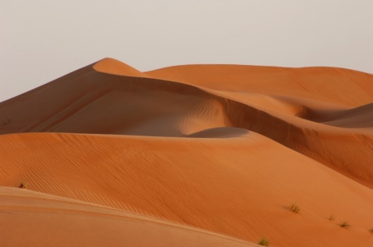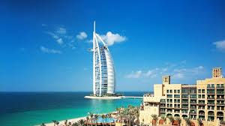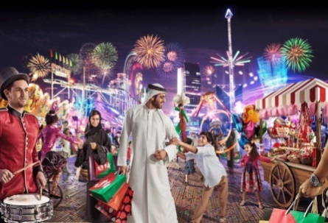
(DAY 01) 24th Nov 2016- Thursday – Arrival
Upon arrival pick up from outside the Dubai international airport and transfer to your hotel
Check in at your hotel- Hotel check in time is 15:00 hrs and early check in will be subject to availability
Overnight stay at hotel of your choice in Dubai
(Day 02) 25th Nov 2016- Friday – Half Dubai City tour- Desert Safari (B/L/D)
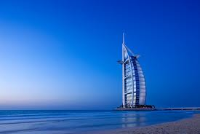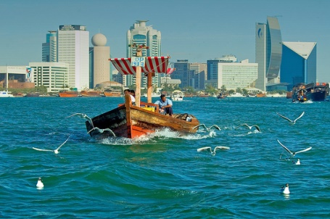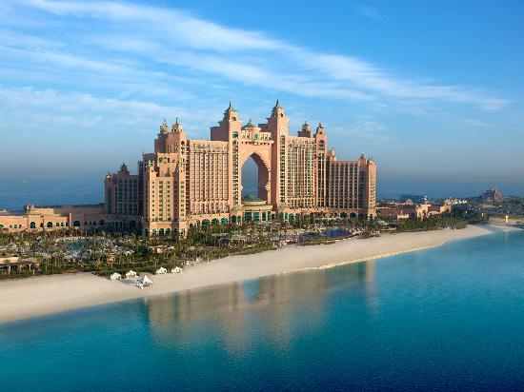
Breakfast at your hotel
09:00 Pick up from your hotel and proceed to Dubai city tour
09:30 Visit 124th floor observation deck of Burj Khalifa
10:30 Proceed to Old Dubai
11:00 Visit Dubai museum
11:45 Take Abra Drive to in Dubai
12:00-12:30 Visit gold souk and spice market
13:00 Buffet lunch at local hotel
14:00 Drop back to your hotel

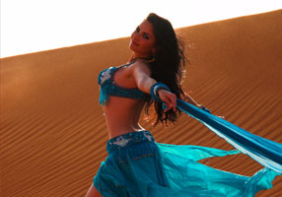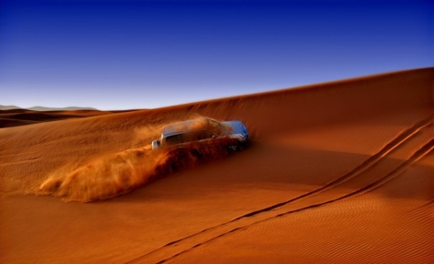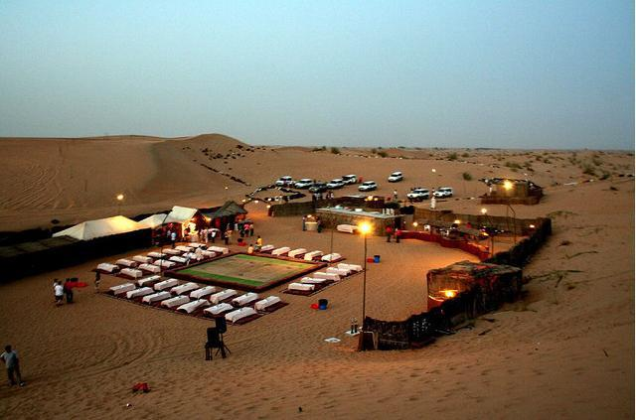
14:00-14:30 Pick up from your hotel by our professional English speaking Safari driver and proceed to Desert safari(nonexclusive 06 pax in a Jeep) Dune bashing drive will be followed by desert camp with barbeque dinner, belly dance, henna painting, shisha pipes, camel ride and Tanoura dance.
20:30 Drive back to your hotel
Overnight stay at your hotel in Dubai
(Day 03) 26th Nov 2016- Saturday – Abu Dhabi (B/L)
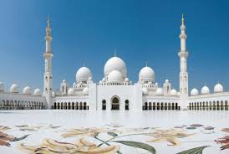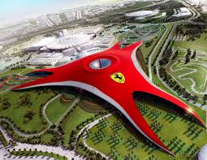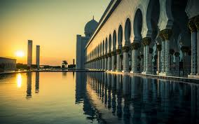
Moring breakfast at your hotel
08:30 Pick up from your hotel by our professional guide and proceed to Abu Dhabi.
Abu Dhabi city tour includes, Shiekh Zayed Grand mosque, heritage viallage, outside photo stop of Emirates place hotel.
12:30 Buffet lunch with water at 4* std restaurant at Abu Dhabi
13:45 Drive to Ferrari world
14:00-17:00 Enjoy rides at Ferrari world- General entry tickets are included.
17:15 Drive back to your hotel
Overnight stay at hotel of your choice in Abu Dhabi

(Day 04) 27th Nov 2016- Sunday – F1(B)
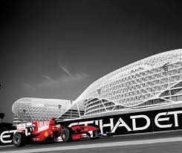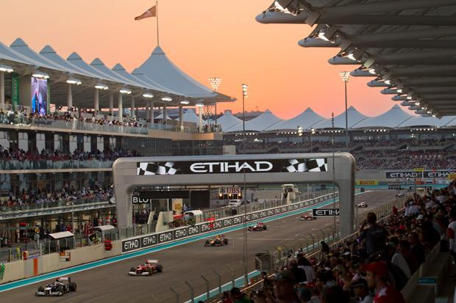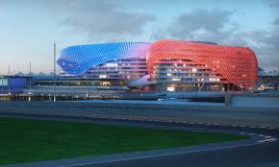
Breakfast at your hotel
Two way transfer to Yas Marina Circuit
(Formula 1 tickets are not included in the package – tickets rates are yet to be published)
13:00 Drive back to your hotel
Overnight stay at hotel of your choice in Abu Dhabi
(Day 05)28th Nov 2016- Monday – Departure (B)
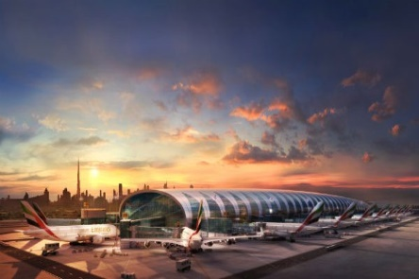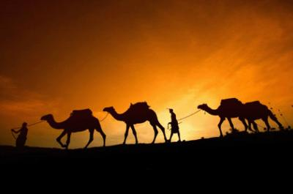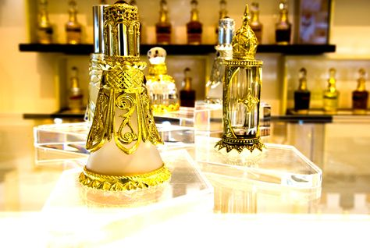
Breakfast at your hotel
12:00Check out from your hotel
Pick up by our professional English speaking driver and transfer to Dubai international airport for departure.
End of the tour

Package cost Per Pax
24-28 Nov 2016(04 Nights)
Package | Hotel | Room Category | Rate per pax sharing Double occupancy – USD |  | Single supplement - USD
 |  |  | 10 | 15
Gold | Habtoor Grand Beach Resort and Spa***** | Club room | 1689 | 1633 | 1245
 | Atlantis the Palm ***** | Palm Beach Deluxe room | 2626 | 2570 | 2182
Silver | Habtoor Grand Beach Resort and Spa***** | Tower room | 1381 | 1326 | 937
 | Atlantis the Palm ***** | Ocean Deluxe room | 2570 | 2514 | 2126
Bronze | Habtoor Grand Beach Resort and Spa***** | Resort room | 1265 | 1209 | 821
 | Atlantis the Palm ***** | Deluxe room | 2439 | 2384 | 1995
- Rate includes:
- Accommodation
- 04 NIGHTS accommodation in given hotels on double sharing basis under BB
- Single supplement has given separate
- Minimum night stay policy is applicable
- Transportation in the 28 seater coaster
- Entry tickets and meals as per the itinerary
- Rate does not include:
- Flight tickets and VISA charges
- Any other services which is not mentioned in cost includes
- TIPS
- All the special room request like smoking, non-smoking, twin etc will be subject to availability at the time of check in
- Hotel standard check in time is 15:00 hrs and check out time is 12:00 hrs
- No services are blocked as of now and the same will be subject to availability at the time of reservation.

